New SPI Data Reveals Growth in Data Openness —and Stubborn Gaps in Critical Data Sources
Adam Landau, Zander Prinsloo, Umar Serajuddin, Brian Stacy
SPI Introduction:
- Introduce the SPI: Pillars, economies, and useful links
- Give short, snappy summary statistics - minimalist introduction showing a quick snapshot
- Highlight the overall landscape of SPI improvement in the last paragraph.
Where do countries stand?
- Heterogeneity in SPI scores based on income levels
  - Higher-income countries dominate; lower-income countries are lagging behind
- However, lower to middle-income countries are catching up and converging
  - Marginal gains since 2016 are higher for lower to middle-income
  - Why? Increased investment in less developed systems yield higher marginal gains
What pillars are driving most of the gains?
- Data services has increased in most countries
  - Most prominent in Africa, and MENA regions
- However, growth rate for data sources has not increased at the same rate
  - Whilst censuses have remained relatively stable, surveys have decreased in many low to lower-middle income countries
  - Likely due to the COVID effect - countries had difficulty co-ordinating the production and dissemination of key statistical products
Low resources are not the be-all-and-end-all: Low-income countries can drive change
- Whilst some countries have struggled low statistical capacity, countries with lower incomes can obtain high SPI scores
  - How? Opening their data practices, modernising their statistical systems
- Observe SPI vs log GDP per capta - find residuals that are furthest away from trend line
  - Use Burkina Faso as an example: $1,000 GDP per capita (low income), but has an SPI score on par with upper-middle/high-income countries
  - How? A rigorous, well-developed statistical roadmap ahead that outlines how to progress with statistical ecosystems.
  - Result: Increase in SPI score from 49% in 2016 to 76% in 2024

On November XXX, 2025, the World Bank launched the latest data for the Statistical Performance Indicators (SPI). The SPI offers a transparent way of assessing national statistical systems, with over 50 indicators tracking 187 economies from around the globe. The SPI breaks down national statistical performance into five pillars and 22 dimensions, each backed by open data and code. Dive into the SPI data here or learn more about the framework to see how countries rank.
The 2025 SPI release features data from 2024 and updates from previous years, compiled with insights from global partners (including the World Bank, IMF, and UN). It’s grown to include 188 economies, up from 167 in 2016, and now covers over 99% of the world’s population.
SPI scores have improved worldwide by an average of 12.5% since 2016, largely driven by gains in data services. North America and Europe & Central Asia rank highest, with East Asia & the Pacific and Latin America & the Caribbean following. While wealthier nations perform best, lower- and lower-middle-income countries have shown the fastest statistical improvement—a promising sign for global data equity.

- Where do countries stand?
As of 2024, SPI scores vary - depending on income levels. High-income regions - mainly Europe, North America and Australia - have the highest SPI scores. Conversely, regions - with low to middle income countries (LMICs) - such as, East Asia & Pacific, Middle East & North Africa and Sub-Saharan Africa are the lowest. From 2016 to 2024, the (unweighted) average SPI scores in low-income nations increased by 10 percentage points – compared with 12 percentage points for high-income nations.
Why does income tend to generate higher SPI scores? One hypothesis is that high-income nations - as proxied by GNI - bring in larger tax revenues. This can be spent on improving the National Statistical Systems (NSS) by upgrading data infrastructure – for instance, purchasing more computers, hiring NSO staff and improving data collection.
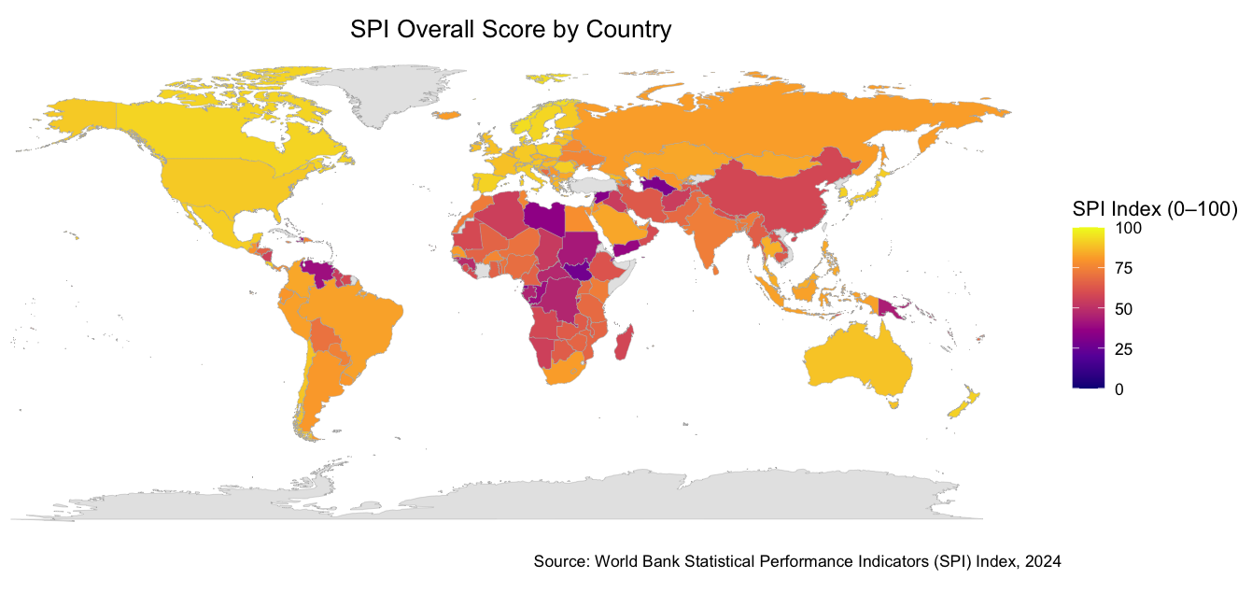
SPI Overall Score by Country: 2024
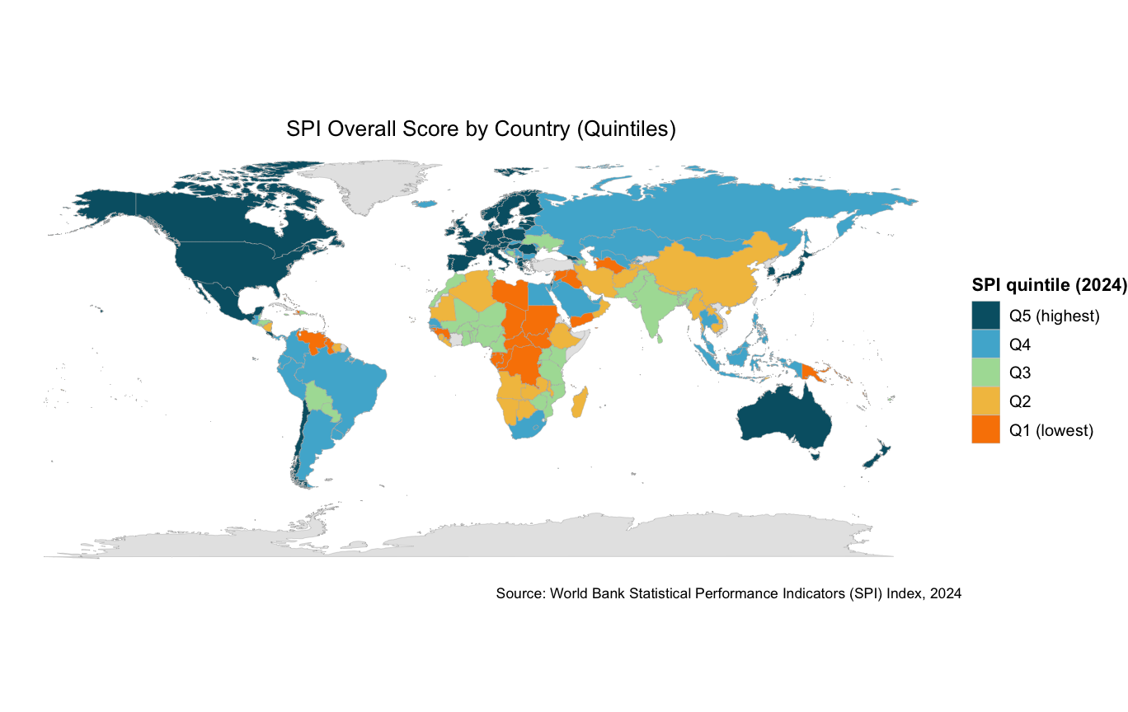
SPI Overall Score by Quintiles: 2024
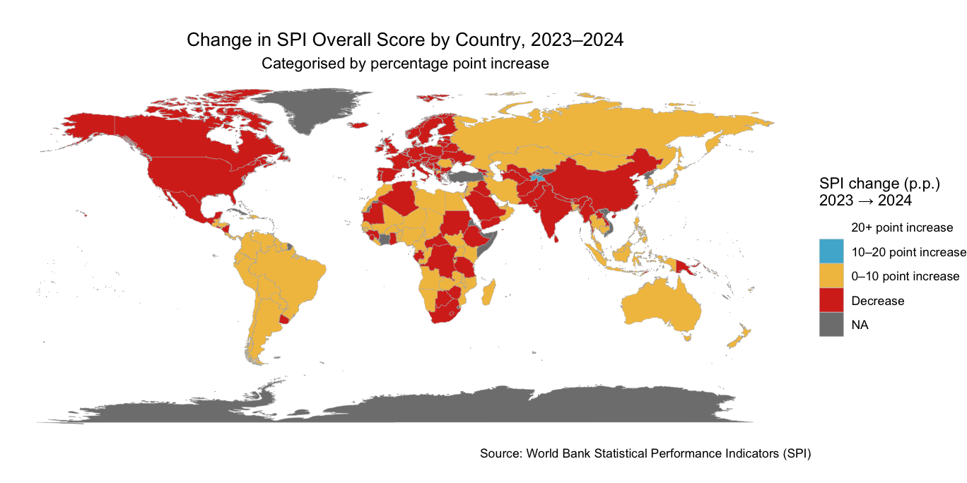
SPI Overall Score Growth: 2023-2024
However, SPI growth has been driven by lower & middle-income countries. In these countries, spending has a much higher impact. An additional staff member has a far bigger impact at an NSO of 5 workers than an NSO of 500. Consequently, lower- to upper-middle countries in Latin & Central American Africa, Eastern European and South Asia have realised most SPI gains.
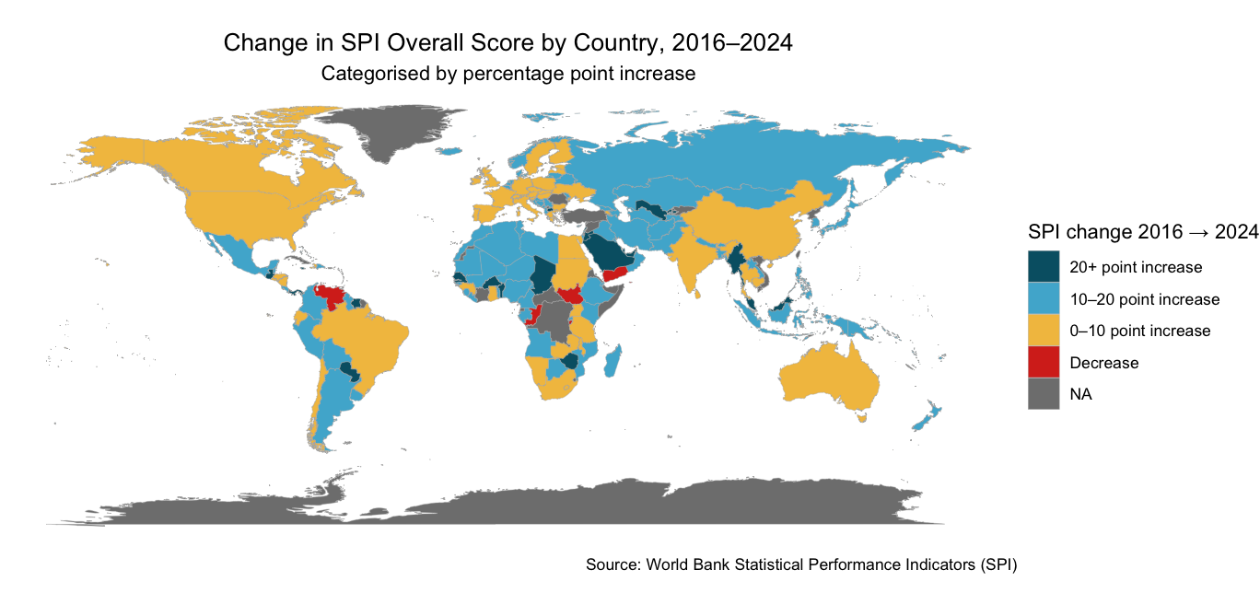
SPI Overall Score Growth: 2016-2024
Top 10 largest changes since 2016:
Country | SPI 2024 | SPI 2016 | Change (p.p.)
Uzbekistan | 80.49 | 37.73 | 42.76
Saudi Arabia | 83.29 | 42.70 | 40.59
United Arab Emirates | 79.15 | 46.70 | 32.45
Marshall Islands | 43.54 | 16.58 | 26.96
Burkina Faso | 76.37 | 49.47 | 26.90
Senegal | 81.41 | 55.08 | 26.34
Zimbabwe | 66.80 | 41.31 | 25.49
Lebanon | 57.81 | 32.74 | 25.07
Chad | 53.57 | 28.50 | 25.06
North Macedonia | 87.17 | 62.61 | 24.57

2. What pillars are driving most of these gains?
The SPI framework assesses the maturity and performance of national statistical systems in five key areas, called pillars. The five pillars are: The SPI is broken down into five separate pillars: i) Data Use, ii) Data Services iii) Data Products iv) Data Sources v) Data Infrastructure.
What pillars of the SPI score are driving most of these gains? Since 2016, the Data Services score has increased by an average of 25 percent, disproportionately driven by countries with mid to low SPI scores. For example, Data Openness - as proxied by the ODIN openness score - has risen by approximately 66% from 2016. This is somewhat promising; it suggests that lower-scoring countries are catching up and converging to their higher-income counterparts.
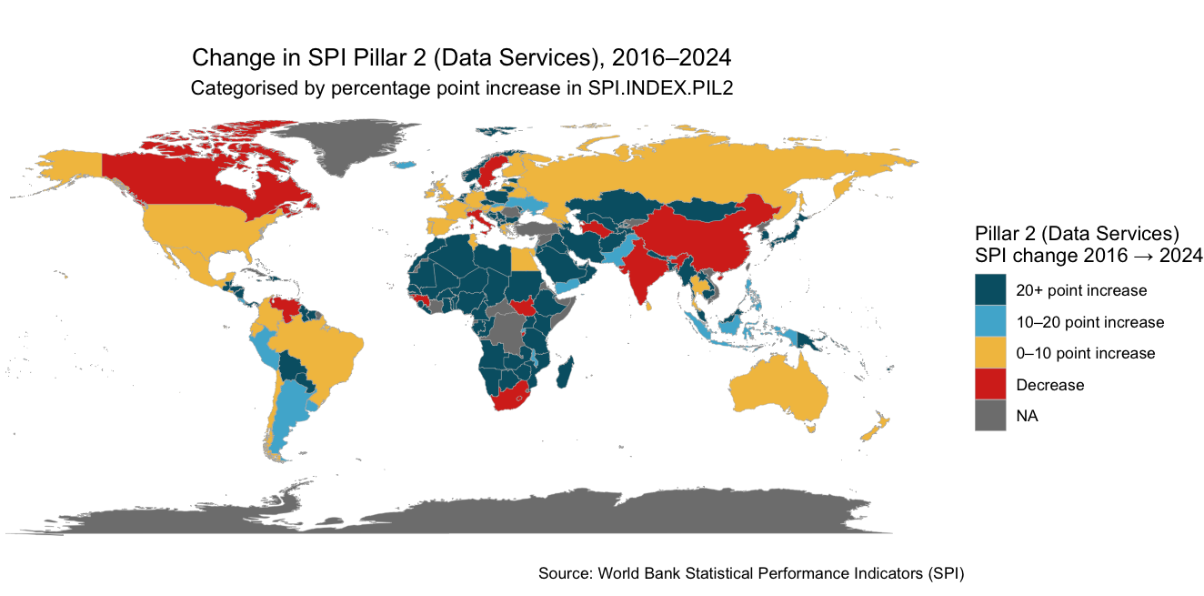

SPI Data Services Score Growth: 2016-2023
Despite certain SPI Pillars improving, not all SPI Pillars have followed suit. In particular, the overall growth of Data Sources has stalled, growing only 3% since 2016. This is partly attributable to the pandemic. COVID severely disrupted National Statistical Offices' ability to collect data, particularly in LMICs where COVID exacerbated the impact of limited data infrastructure. Data shows only a handful of countries have grown their Data Sources figures by more than 10 points. Most countries have grown 0-10 points or declined.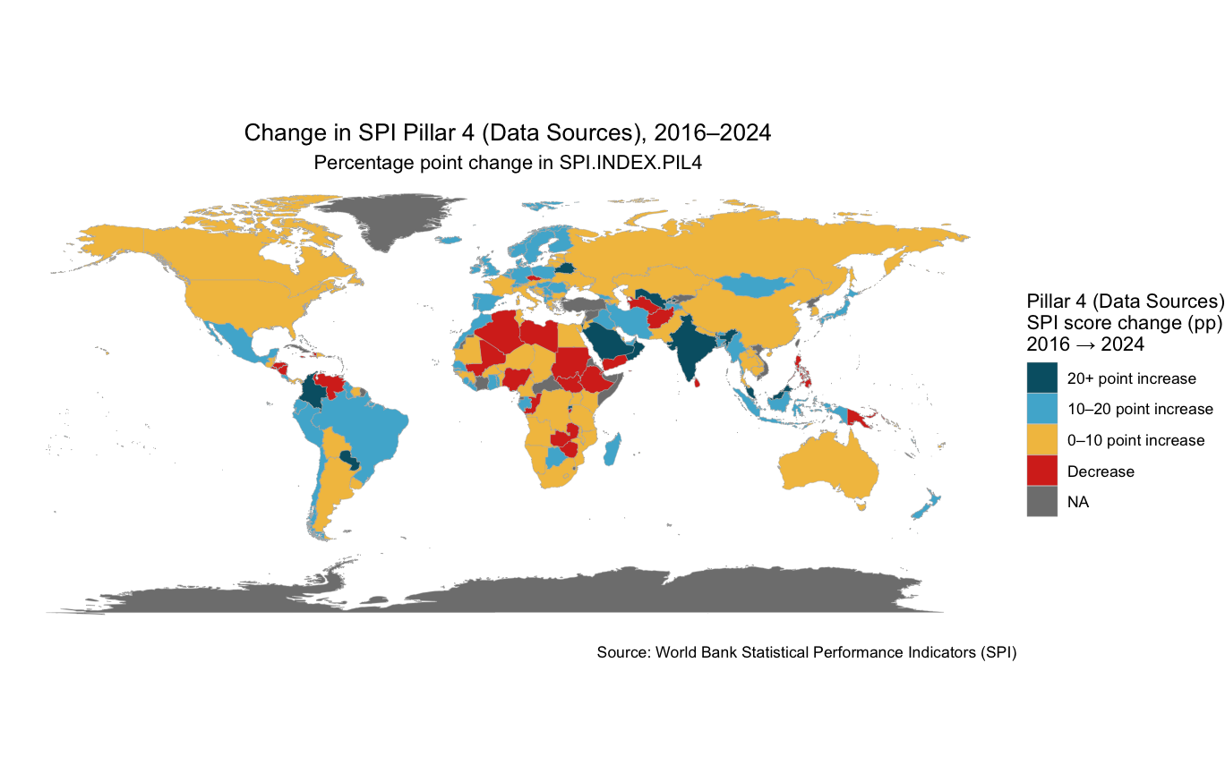SPI Data Sources Score Growth: 2016-2024
The hit to data sources has been largely uneven - in particular SPI survey scores. COVID delayed country capacity to produce timely, accurate and granular statistics, particularly in LMICs where it exacerbated the effects of low data infrastructure. 63% of NSOs in high-income countries reported disruptions in their statistical production due to the pandemic, whereas this figure stood at 88% for NSOs in LMICs — 25 percentage points higher. Untimely statistics - especially during periods of crisis - delay decision-making which are crucial for effective response measures. Unsurprisingly, countries with the lowest statistical capacity scores were the hardest hit; most of these countries still have not recovered.
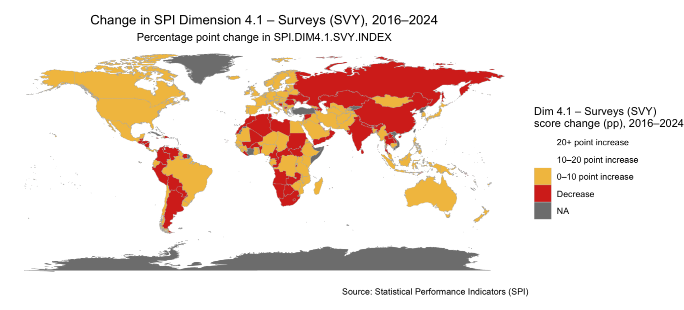
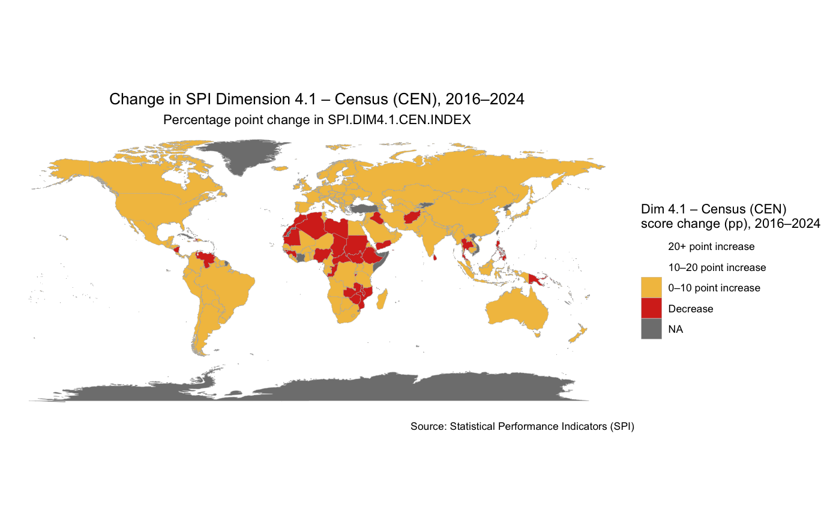
3. While resources are an issue, some countries have persevered: Income vs SPI
Income-level is a key predictor of statistical capacity. However, certain LMICs – like Burkina Faso, Rwanda and the Philippines – have performed better than the general trend.
Why are these countries outliers? Take Burkina Faso. The National Institute of Statistics and Demography (INSD) has adopted novel digitalisation and innovative methods for data collection. This resulted from the well-developed 2021-25 ‘National Strategy for the Development of Official Statistics’ (Schéma Directeur de la Statistique 2021–2025). Over this period, the INSD i) modernised statistical databases ii) increased geospatial data availability and iii) enhanced IT infrastructure. The INSD has taken a proactive approach to upskilling and digitalising their statistical ecosystem. As a result, Burkina Faso has become a regional leader in data collection efforts - increasing their SPI score from 49% in 2016 to 76% to 2024 - and serves as a model for other LMICs to increase uptake of data to drive sustainable development.
Ultimately, the SPI can assist with these developments. By tracking what gets measured, the SPI helps countries identify gaps in their statistical ecosystem, and plan how best to address them.

